

***INSTITUTE OF INFORMATION TECHNOLOGY***

***JAHANGIRNAGAR UNIVERSITY***

**Assignment :** 02

**Submission Date :** 05/12/2021

**Course Tittle :** Computer Architecture

**Course Code :** ICT - 2207

**Submitted To Submitted By**

Md Biplob Hosen Md. Shakil Hossain

Lecture Roll – 2023

IIT – JU 2nd year 2st Semester

IIT – JU

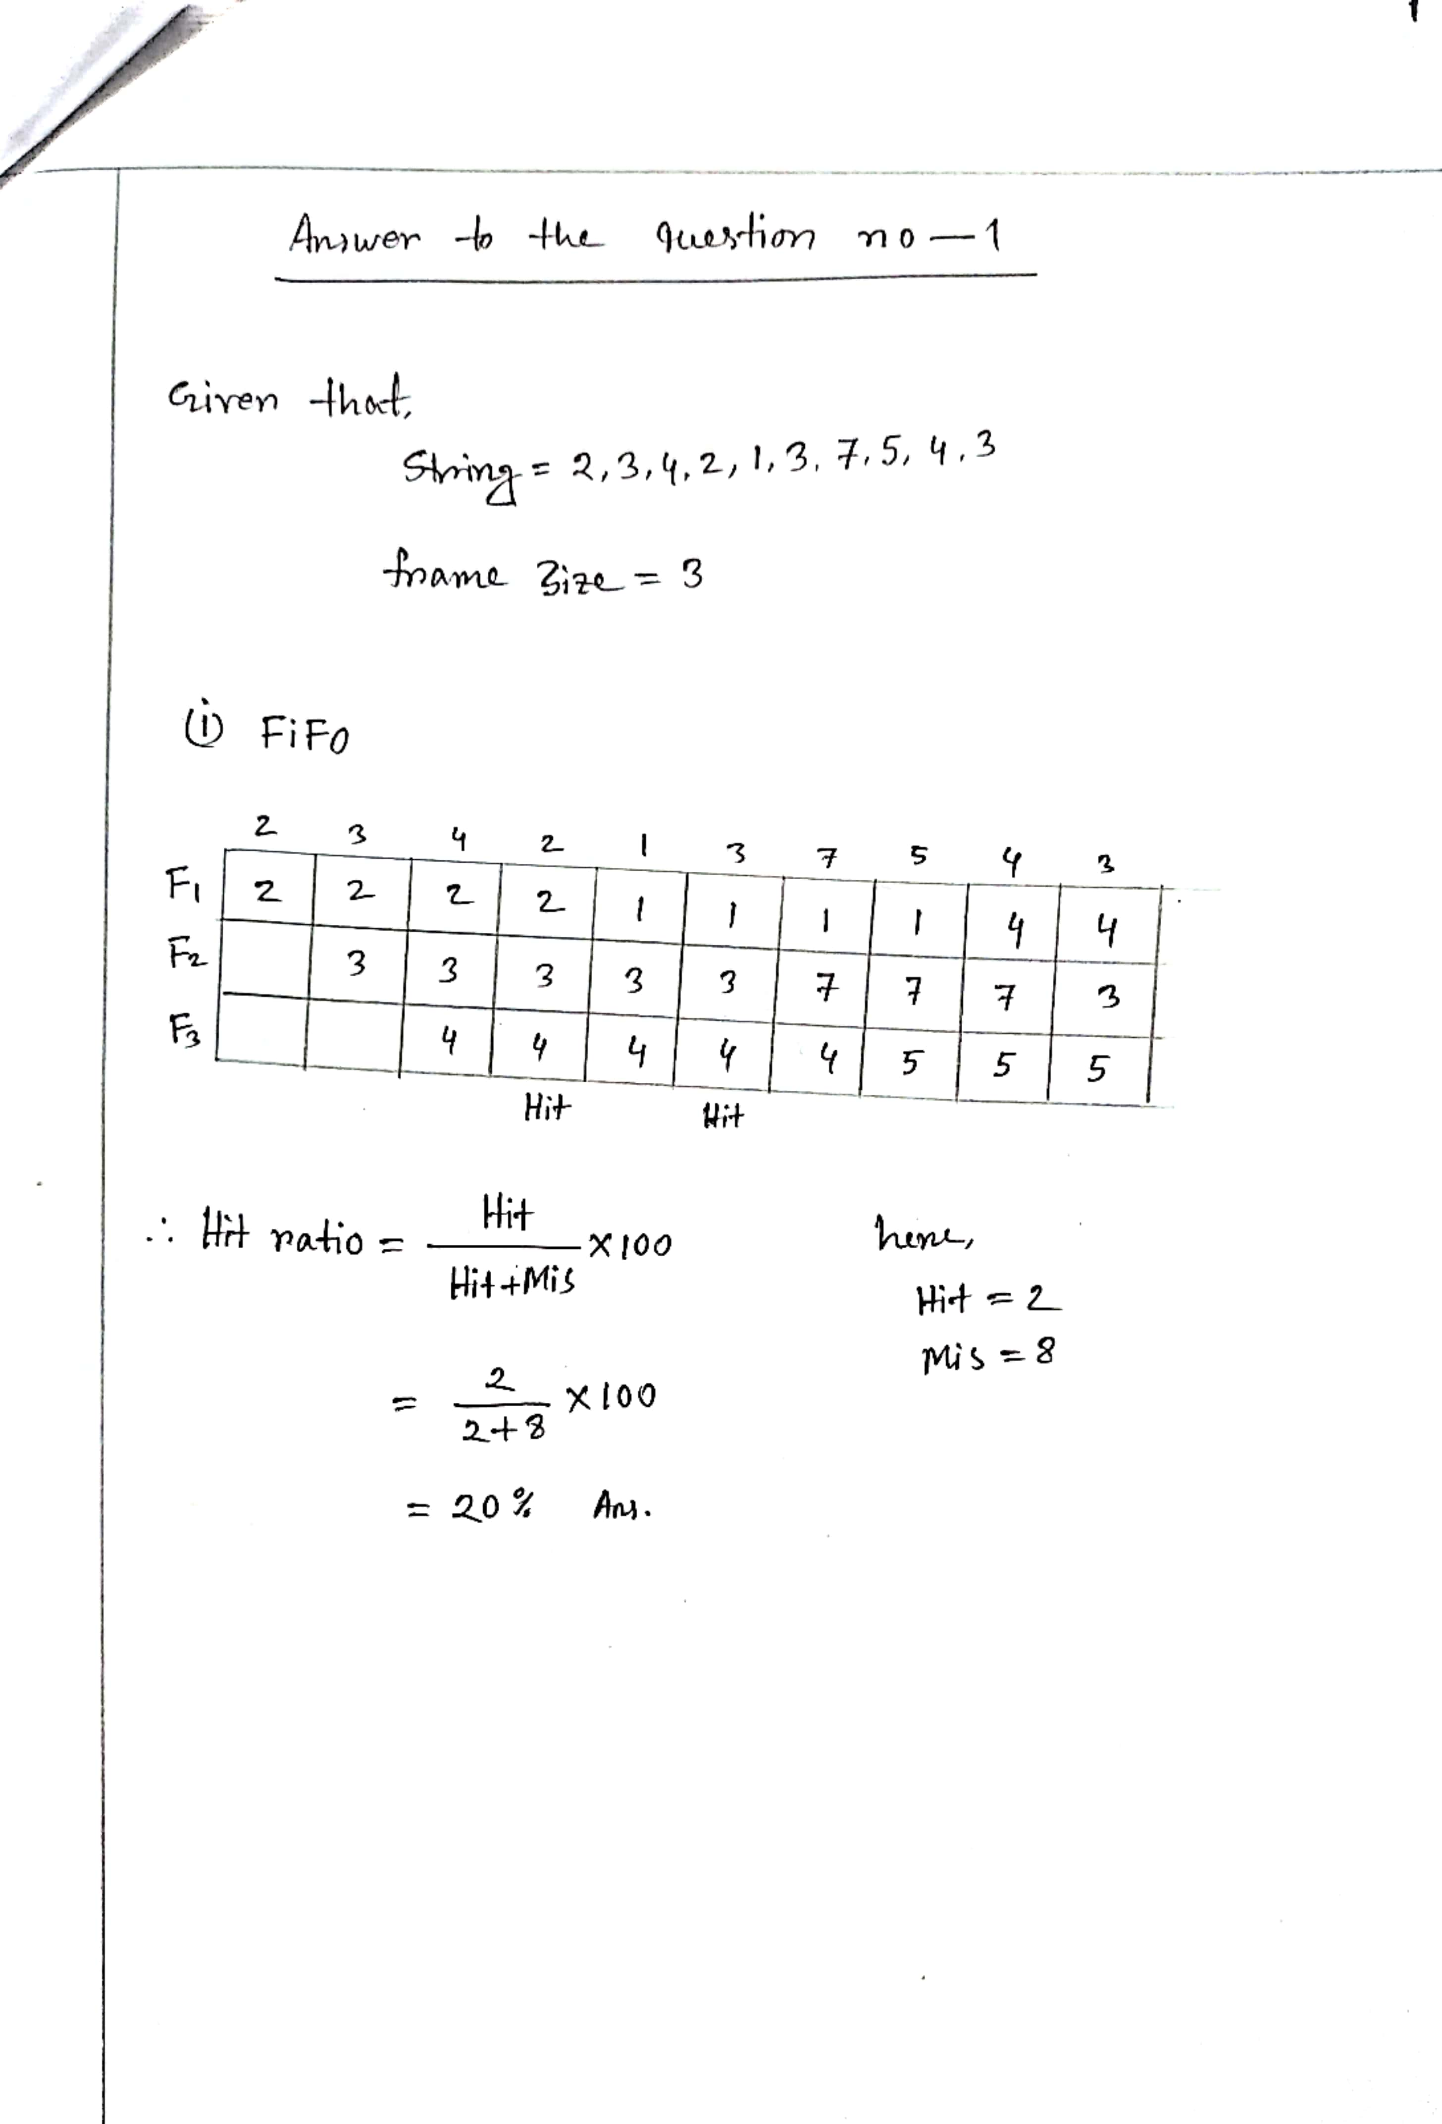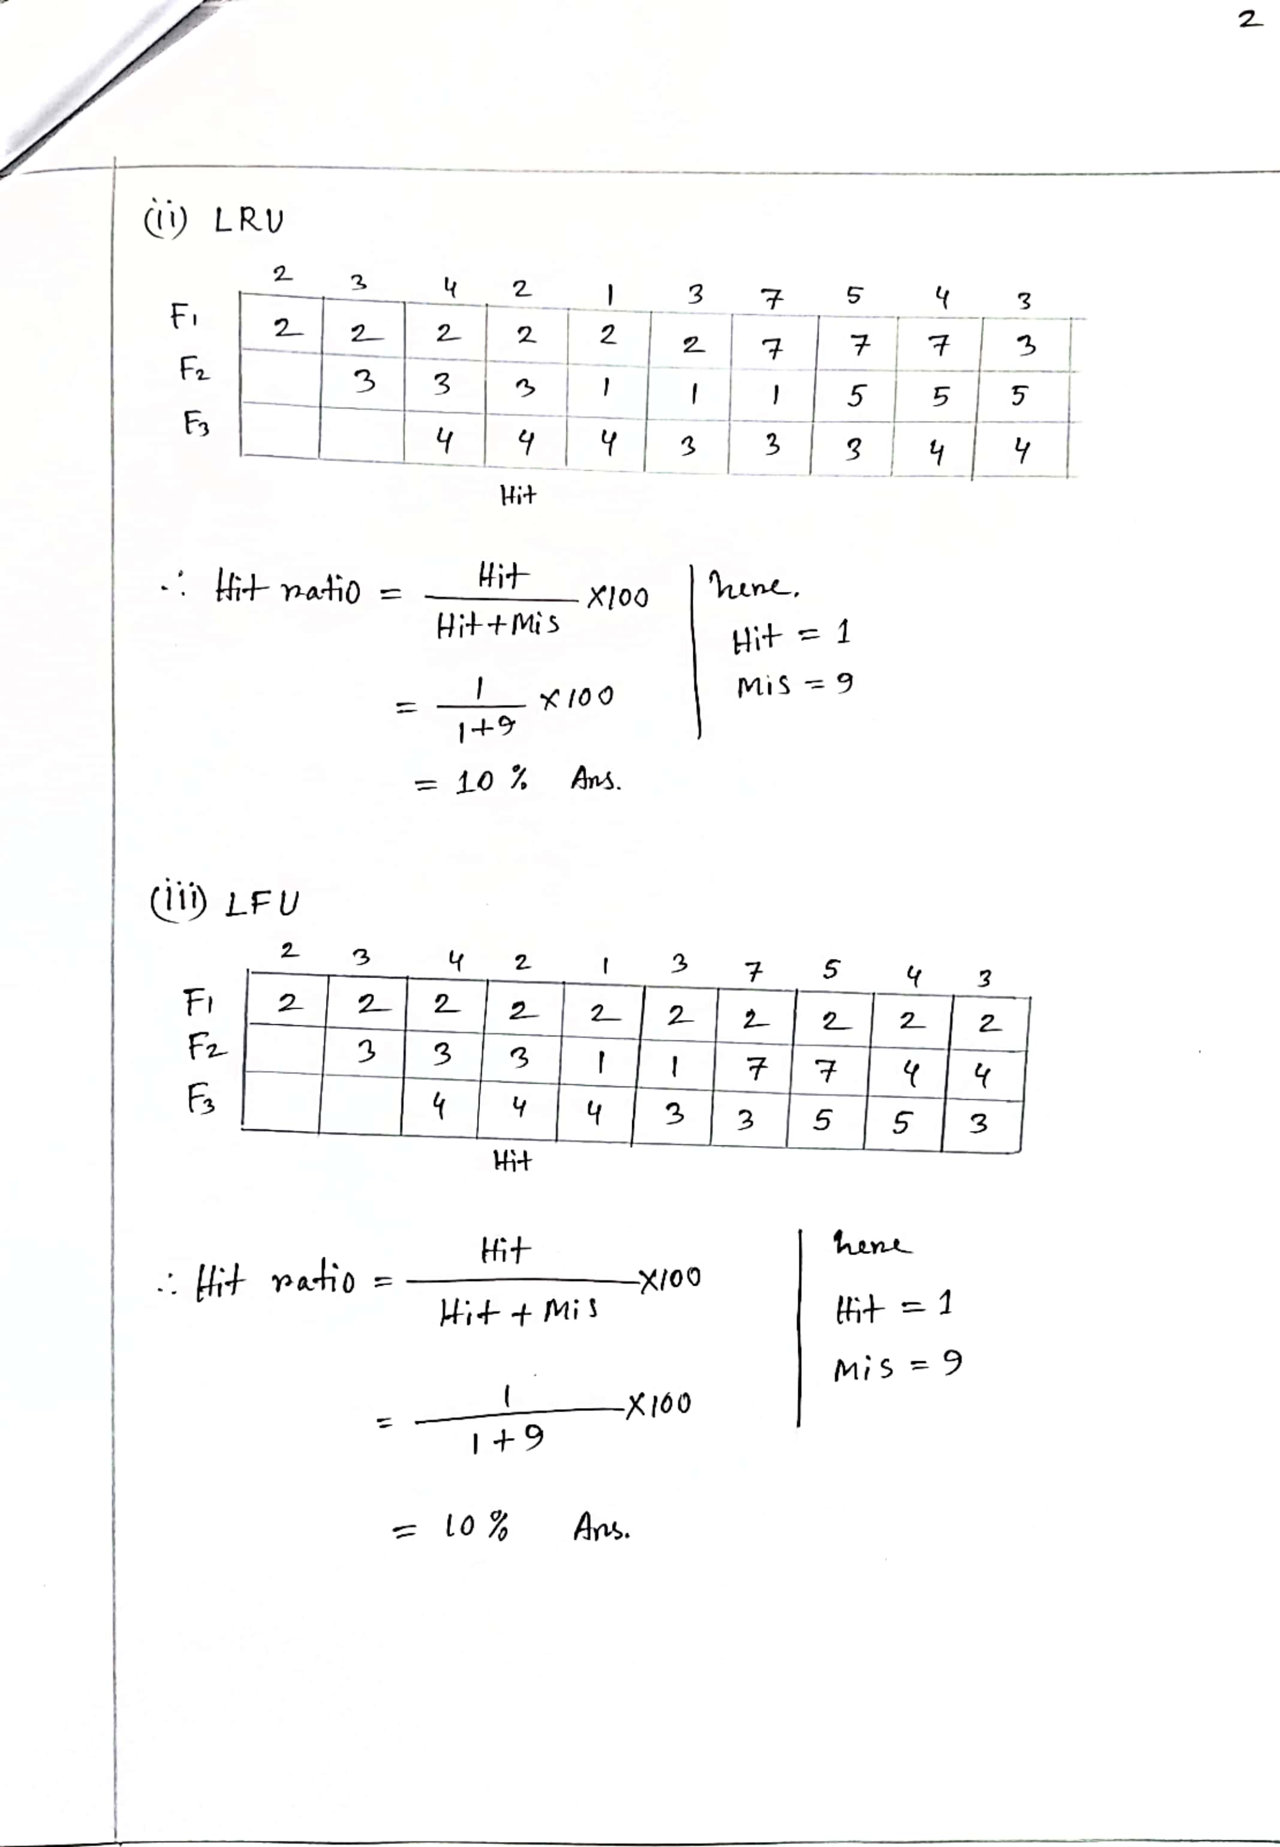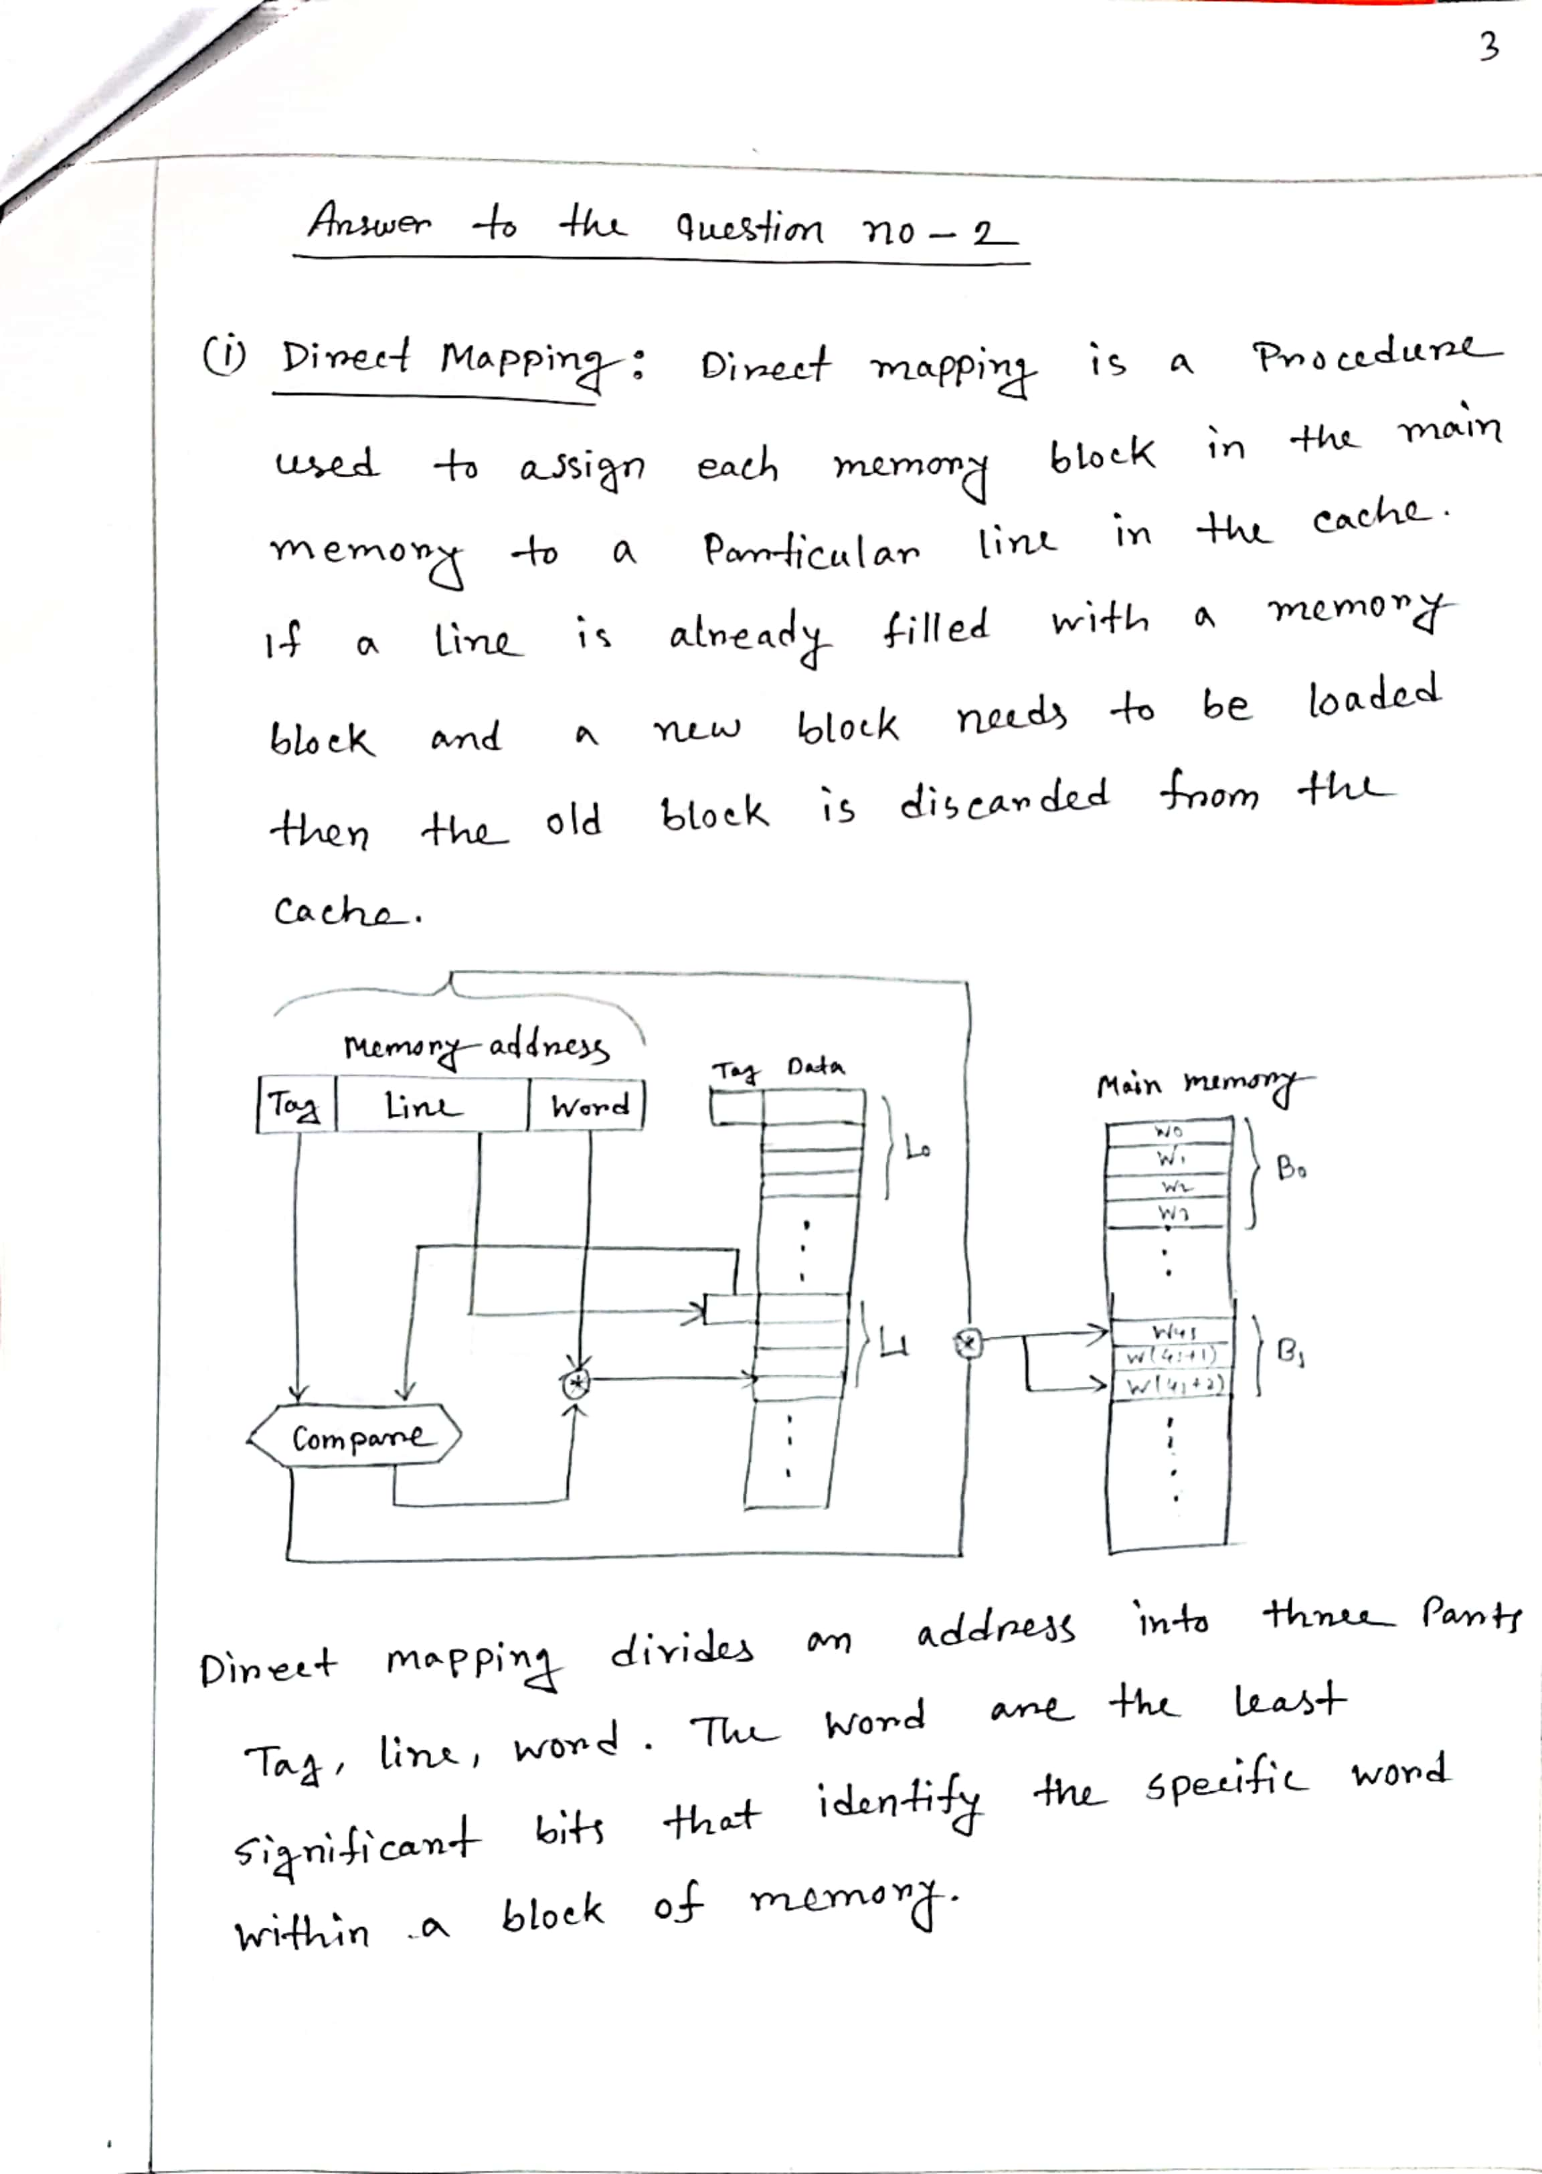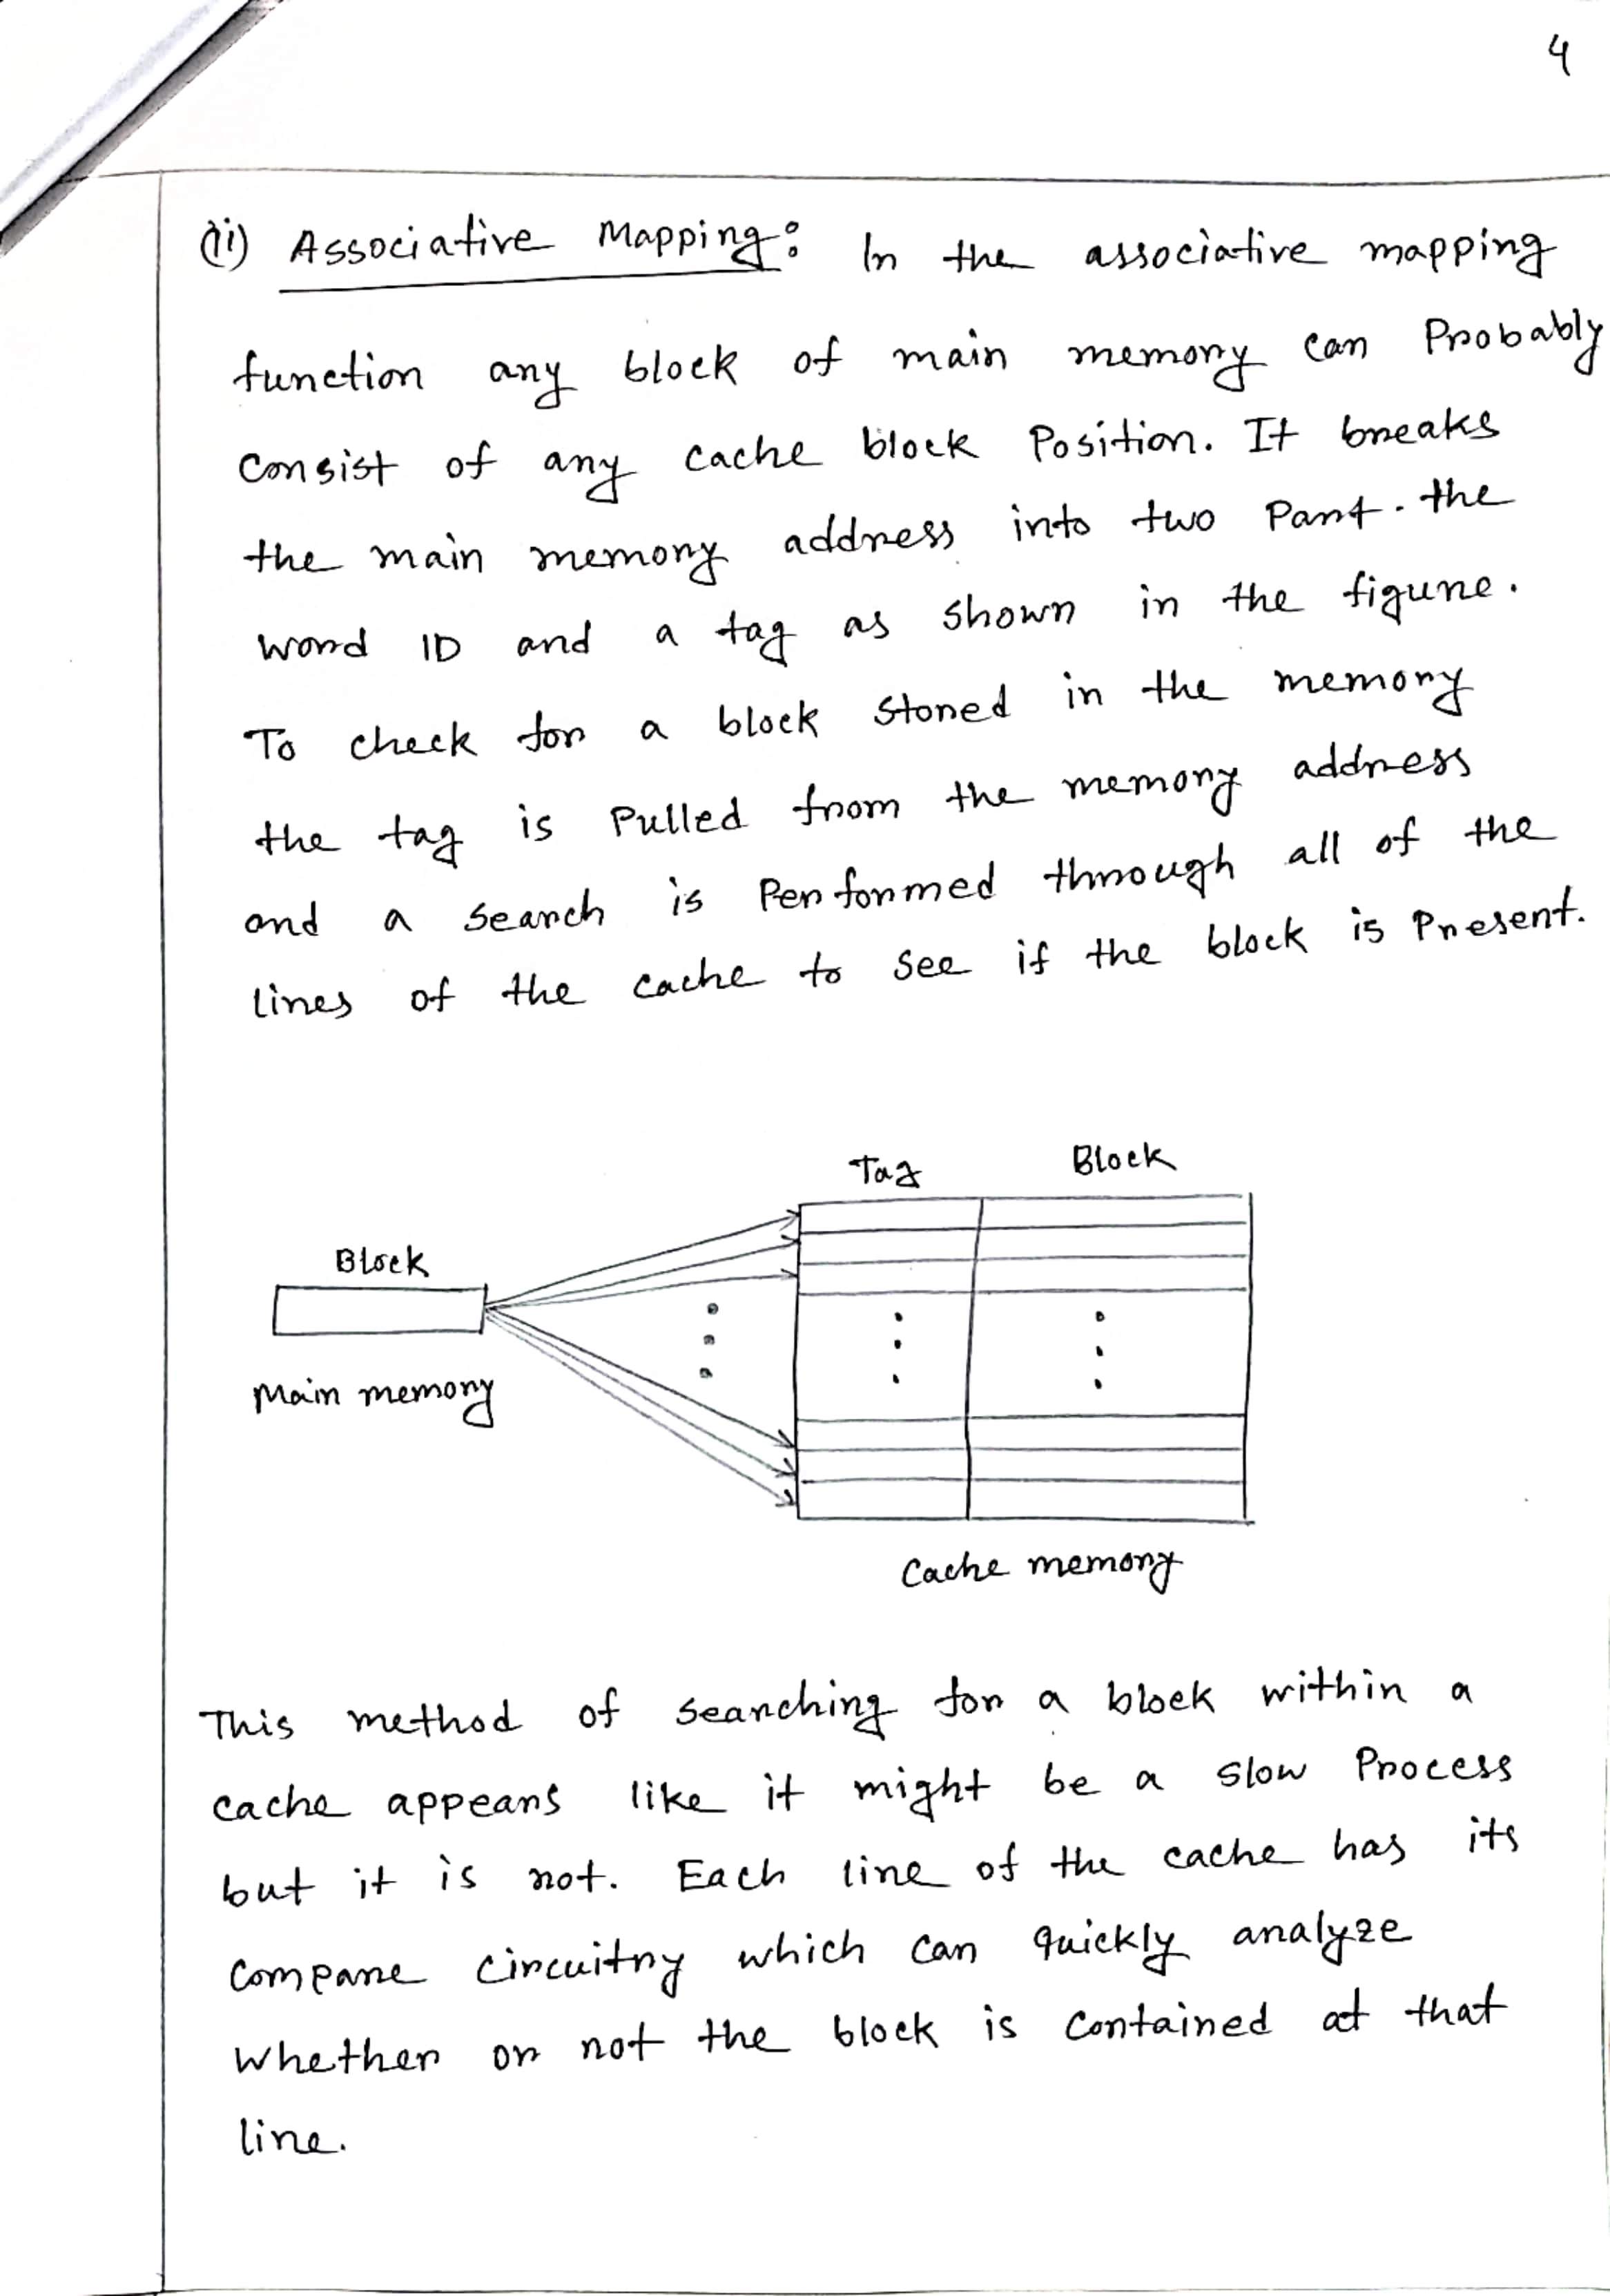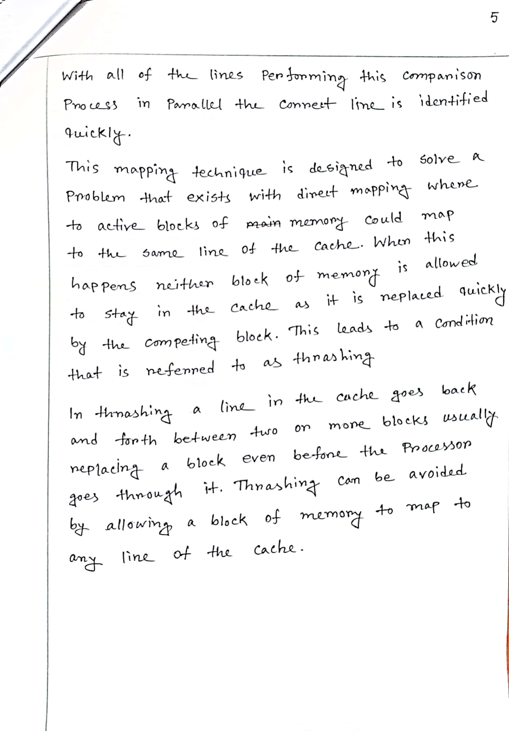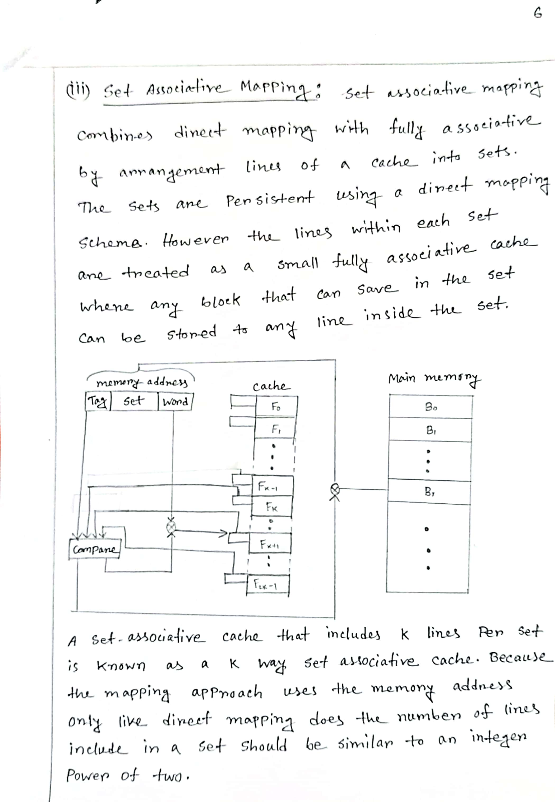

**THE END**